Each person pictured is doing something that they like to do. Write a sentence for each one. Remember the rules of GUSTAR.

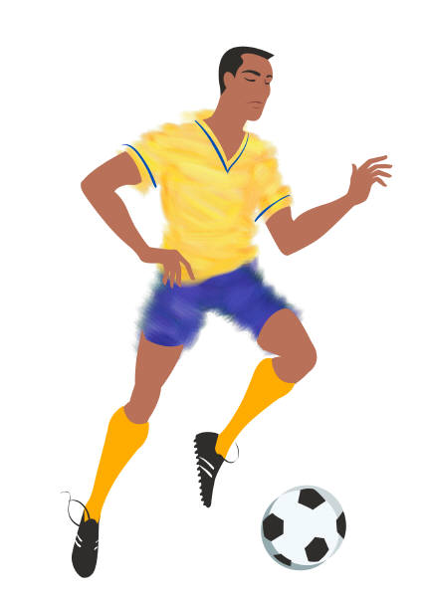
1.Oscar 2.Pedro y yo 3. Jorge 4.Mi papá 5. Ana
6. Nosotros 7. Yo 8. Lola y Juan 9. tú y yo 10. tú

11. Andrés 12. Nosotros 13. Lisa 14. Beto y Miguel 15. mi mamá

1.______________________________________________________________________
2. ______________________________________________________________________
3.______________________________________________________________________4. ______________________________________________________________________
5. ______________________________________________________________________
6. ______________________________________________________________________
7. ______________________________________________________________________
8. ______________________________________________________________________
9. ______________________________________________________________________
10. _____________________________________________________________________
11. _____________________________________________________________________
12. _____________________________________________________________________
13. _____________________________________________________________________
14. _____________________________________________________________________
15. _____________________________________________________________________

